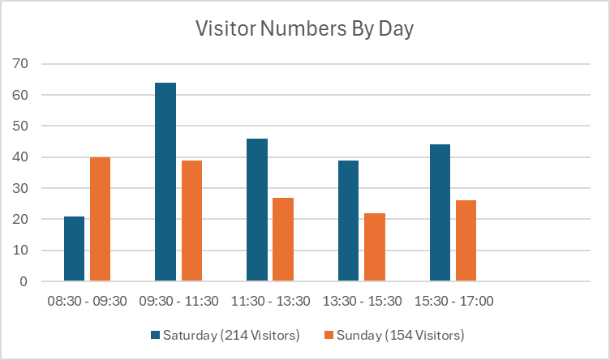

**Key headlines**

* 368 visits over 2 days, equivalent to 40,000 visits pa
* 78% visitors come at least once a week
* 37% visitors walk to the woods, 56% come by car
* Highlights this is a much loved, local asset
* Numbers suggest significantly higher visitor numbers

per hectare compared to other local open spaces

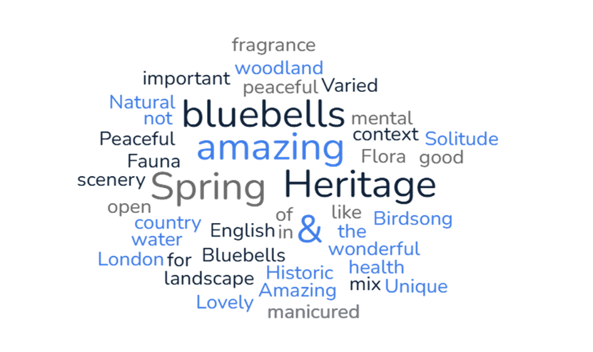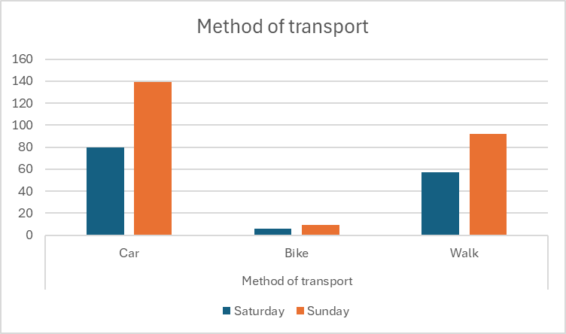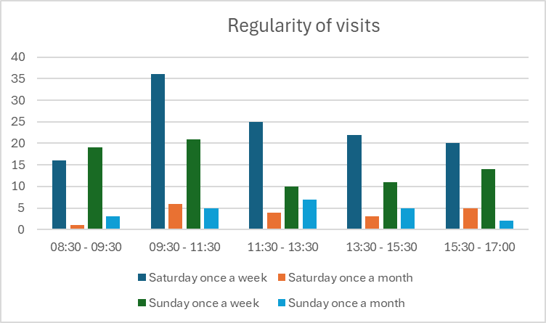

**Further information** via QR or: [www.fishpondwood.org](http://www.fishpondwood.org).

**Visitor feedback**